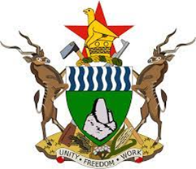 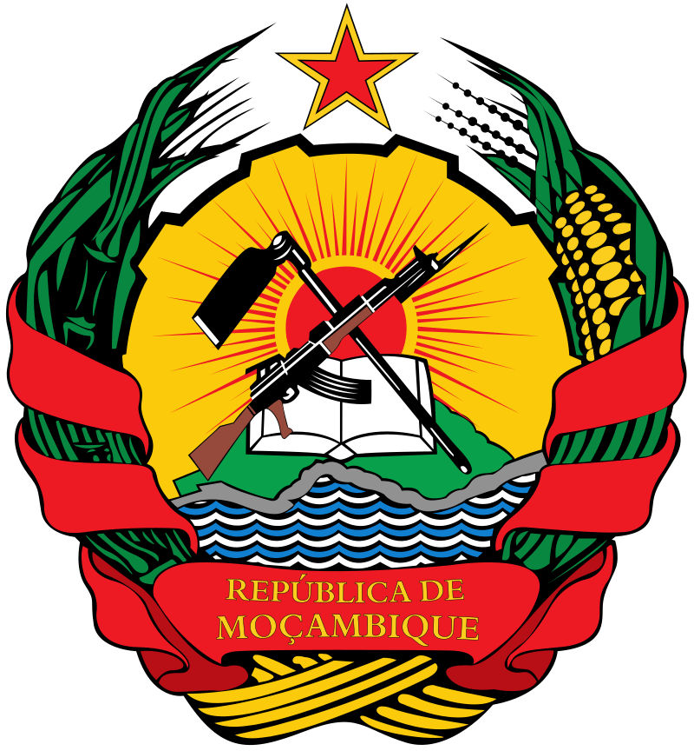

**Joint Communiqué of the signing ceremony of the Memorandum of Agreement of the Zimbabwe Mozambique Zambia Transfrontier Conservation Area by the Partner States, The Republic of Zimbabwe, Republic of Mozambique and The Republic of Zambia**

**ON 18 JULY 2024**

1. At the historic signing of the Memorandum of Agreement (MoA) of the Zimbabwe, Mozambique and Zambia (ZIMOZA) Transfrontier Conservation Area (TFCA) which was held on 18th of July 2024 at State House in Harare, Zimbabwe.
2. The Agreement signing was chaired by HE Dr Emmerson D. Mnangagwa, President of the Republic of Zimbabwe in his capacity as host.
3. The MoA was signed by the following Heads of State and Government and all their representatives

Zimbabwe H.E. President Dr. Emmerson D. Mnangagwa,

Mozambique H.E. President Filipe J. Nyusi,

Zambia H.E. President Hakainde Hichilema,

1. Cabinet Ministers of Partner States, SADC Executive Secretary, Senior Officials, Diplomatic Corps, Traditional Leaders, Collaborating Partners, Local Authorities, Civil Society organisations and Faith based organisations witnessed the signing.
2. ZIMOZA -TFCA measuring approximately 39 165 km2 covers districts of Mbire, Muzarabani, Guruve, Mt Darwin and part of Makonde (wards 1, 2 and 11) in the Republic of Zimbabwe, the Administrative Posts of Zumbo-Sede and Zâmbue in Zumbu District; the District of Mágoè in its extension and at the level of the District of Cahora Bassa, the locality of Nhabando in the Administrative Post of Chitima in the Republic of Mozambique and Luangwa and Rufunsa Districts in Republic of Zambia.
3. This achievement is consistent with the Southern African Development Community (SADC) Protocol on Wildlife Conservation and Law Enforcement and SADC Protocol on Environmental Management for sustainable development that urges Partner States to collaborate as well as promote conservation of shared wildlife resources through establishment of TFCAs.
4. The signing of the MoA reaffirms the three countries commitment and resolve to the successful development of the ZIMOZA TFCA, which is based on the principle of sustainable use of natural resources to benefit the present and future generations and on the principle of good neighbourliness.
5. In recognising the value of partnerships and strategic alliances in the development of ZIMOZA TFCA, we shall collaborate to achieve the following objectives:
   1. promote biodiversity conservation and to provide for the restoration of the ecosystem;
   2. secure and guarantee the long-term sustainable management and utilisation of the environment and the natural resources and to maintain the ecosystem integrity in the TFCA;
   3. ensure the full realisation of the economic potential of the TFCA which shall bring economic benefits to the Parties especially to the local communities;
   4. Promote cultural heritage conservation, and enhance opportunities for sustainable development in the TFCA;
   5. Develop knowledge management tools for sharing experiences and information among the Parties and stakeholders for the promotion of conservation and sustainable utilisation of natural resources;
   6. Promote cross-border co-operation at community level in order to enhance trade, investment, social, cultural and economic development of the TFCA;
   7. Harmonise policies, legislation and practices of the Parties relating to the sustainable management and utilisation of the environment and natural resources, customs, trade and investment, immigration, tourism and such related issues as are necessary for the implementation of this MoA,
   8. Integrate, as far as possible, the managerial, conservation, research, marketing and other systems of the TFCA into the national plans, policies and programs of the Parties respectively.
6. The Government of the Republic of Zimbabwe agreed to serve as the coordinating country for the next two years on rotational basis to Mozambique then Zambia as provided for in the MoA.
7. The State Parties agreed to set up a Secretariat, and other Institutional Structures including funding mechanism that will facilitate the coordination and joint management of the ZIMOZA TFCA.
8. The host of the Agreement signing H.E Dr E.D Mnangagwa President of the Republic of Zimbabwe expressed gratitude to both the Heads of State and government for attending and signing of the MoA and the political will in advancing conservation management in Protected and Conserved Areas. He further called upon all collaborating Partners to support the development of the ZIMOZA TFCA.

**Done on 18th July 2024**

**Harare, Republic of Zimbabwe**